Ayush Goyal 190905522
CSE D Roll 62

Distributed Systems Week 2: Lab 2: Python Basic Practice-II

Lab Exercise Programs for Week 1 & 2:

1. Write a program to find the area of rectangle. Take input from user.

l = int(input('Enter length: '))
b = int(input('Enter breadth: '))
a = l*b
print('Area of rectangle is: '+ str(a))

Output:

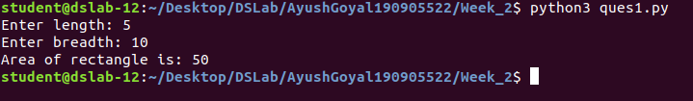

2. Write a program to swap the values of two variables.

a = int(input('Enter value of a: '))
b = int(input('Enter value of b: '))
a,b = b,a
print('Value of a is {0}\nValue of b is {1}'.format(a,b))

Output:

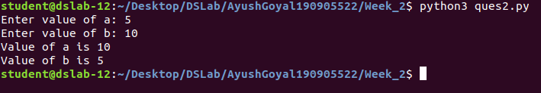

3. Write a program to find whether a number is even or odd.

a = int(input('Enter any number: '))
if(a%2 == 0):
print('Even')
else:
print('Odd')

Output:

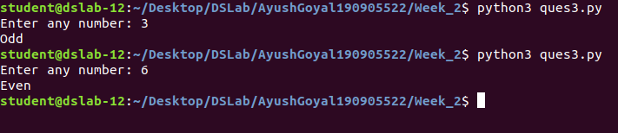

4. Write a program to check the largest among the given three numbers.

x = [int(i) for i in input("Enter 3 user inputs: ").split()]

max = x[0]
for i in range(len(x)):
if max < x[i]:
max = x[i]
print('The largest number is ', str(max))

Output:

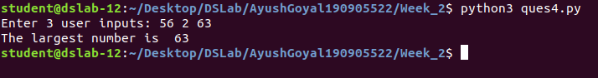

5. Write a program to demonstrate while loop with else.

x = [int(i) for i in input("Enter 3 user inputs: ").split()]
i = 0
while i<len(x) :
if x[i]%2 == 0:
print('Even')
else:
print('Odd')
i+=1

Output:

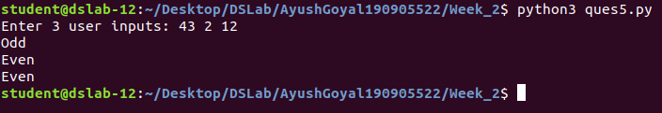

6. Write a program to demonstrate List functions and operations.

x = [int(i) for i in input("Enter 3 user inputs: ").split()]
print(x)
print('Appending 5')
x.append(5)
print(x)
print('Reversing list')
x.reverse()
print(x)

Output:

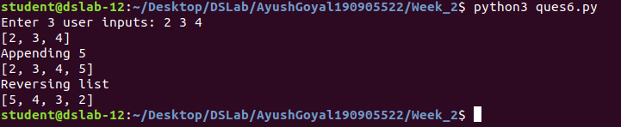

7. Consider the tuple [1,3,5,7,9,2,4,6,8,10]. Write a program to print half its values in one line and the other half in the next line.

x = [1,3,5,7,9,2,4,6,8,10]
print(x[:5])
print(x[5:])

Output:

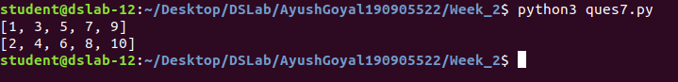
8. Consider the tuple [12,7,38,56,78]. Write a program to print another tuple whose values are even number in the given tuple.

x = [12,7,38,56,78]
y = []
for i in x:
if i%2 == 0:
y.append(i)
print(y)

Output:

9. Write a Python program to print negative numbers in a List using for loop. Eg. [11,-21,0,45,66,-93].

x = [11,-21,0,45,66,-93]
for i in x:
if i<0 :
print(i)

Output:

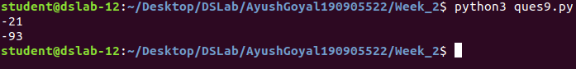

10. Write a program to print negative numbers in a list using while loop.

x = [11,-21,0,45,66,-93]
i=0
while i<len(x) :
a = x[i]
if a<0 :
print(a)
i+=1

Output:

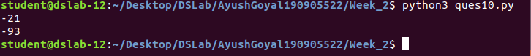

11. Write a python program to count positive and negative numbers in a list.

x = [11,-21,0,45,66,-93]
p,n = 0,0
for i in x:
if i>=0 :
p+=1
else:
n+=1
print('There are {0} positive numbers and {1} negative numbers'.format(p,n))

Output:

12. Write a python program to remove all even elements from a list.

x = [int(i) for i in input().split()]
x = list(filter(lambda i: i%2 != 0, x))
print(x)

Output:

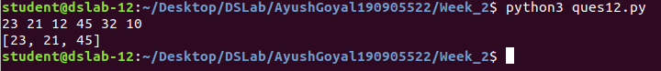

13. Define a dictionary containing Students data (Name, Height, Qualification),
a. Convert the dictionary into DataFrame
b. Declare a list that is to be converted into a new column(Address)
c. Using ‘Address’ as the column name and equate it to the list and display the result.

import pandas as pd

Students = {"Name": ["Ayush Goyal", "Dipesh Singh", "Shiv Baratam"], "Height": ["6'3", "4'5", "5'11"],"Qualifications": ["BTECH", "Mid-School", "12th Pass"]}

new = pd.DataFrame.from_dict(Students)
print(new)
address = ["Kolkata", "Delhi", "Bengaluru"]
new["Address"] = address
print(new)

Output:

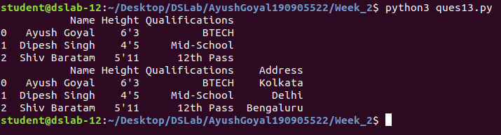

14. Define a dictionary containing Students data (Name, Height, Qualification),
a. Convert the dictionary into DataFrame
b. Use DataFrame.insert() to add a column and display the result.

import pandas as pd

Students = {"Name": ["Ayush Goyal", "Dipesh Singh", "Shiv Baratam"], "Height": ["6'3", "4'5", "5'11"],"Qualifications": ["BTECH", "Mid-School", "12th Pass"]}

new = pd.DataFrame.from_dict(Students)
print(new)
address = ["Kolkata", "Delhi", "Bengaluru"]
new.insert(1,"Address",address)
print(new)

Output:

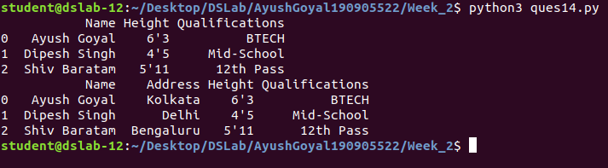

THE END

